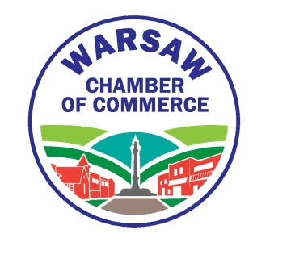
Vendors Wanted

The Warsaw Chamber of Commerce is accepting vendor applications for artisans, crafters, home based businesses, and organizations who would like to participate in the Village’s 7th Annual Valley Fest which takes place Thursday July 18th, Friday July 19th, and Saturday July 20th of 2019. The Warsaw Chamber will provide a sidewalk space of 10’ x 10’, placement will be of the committees choosing, on Main Street or West Buffalo Street during the event. Vendors must be available for all three days and be set up for the entire event time. No items may be left on the sidewalk overnight. Vendors are responsible to provide their own Tent (with weights), tables, chairs if needed and proof of insurance. If you are selected as a vendor there will be a $25 fee which includes all 3 days of the event. Non-profit organizations will have the fee waived if selected. For more information please contact Brandon Zeches at 585-259-5400.

Valley Fest Craft and Vendor Application form

Business Name: ________________________________________________________

Contact Person: ________________________________________________________

Address: ______________________________________________________________

______________________________________________________________________

Phone: __________________________

Email: _________________________________________________________________

Product Description: _____________________________________________________

_______________________________________________________________________

Space Required: 1 Space ($25) 2 spaces ($50)

Please return this form to:
Valley Fest Vendor Application
113. W. Buffalo Street
Warsaw, NY 14569

